CELEBRATION 100 – YEARS FOR THE SOROPTIMISME 1921 - 2021

”We stand up for women in 100 years”

SI Ringsted, Denmark has chosen Karen Inger Callisen – a member since 1984.
She accepted the choice on the condition using her motto: ”Nobody can do everything – all people can do something”!
In SI Ringsted she is a member in the ”ENV – group” to try to follow the trace of sustainability (to-day some of ”UN’s 2030 – World – Goals”), and green nature.

”Danish Plant a Tree”, wanted in 1989: Whole Denmark to make local committees..
Karen Inger Callisen formed in collaboration with local players a committee: ”Plant a tree, Ringsted”,where a soroptimist allways is the chairman. SI Ringsted - 40 years jubilee - suddenly was very well-known.
The aim was:”RINGSTED MUCH MORE GREEN & PRETTY – all people should be GREEN = the trees are INDISPENSASIBLE”!
The first tree was planted in 1989 followed by many green activities, often proposed by SI Ringsted:

In 1991 Ringsted Town celebrated 550 years jubilee, and all newborn babies got a ”Tree of Paradize” to plant.

...2

2...

In 1999 by our 50 – jubilee a ”Drinking – Fountain” was donated by SI Ringsted to the town = ”Without water, no trees, animals or people”.
1999: In 14 institutions young children planted an oaktree for the new millenium.
In 2000 a book was published with 2000 poems, from children: ”What to wish for the new century”.

In 2003 a ”GREEN PAMPHLET” was created in SI Ringsted:
”The Tour in the Trees of Ringsted – a nature-guide for children and adults with a quiz on the trees in Ringsted”. ”Read, Learn, Guess” – importance between trees and life - used at schools. Guided tours in Ringsted.
SI Ringsted was honoured by receiving ”Best Practise Award in Environment 2004 – 2005” from SIE.
Ringsted local commitee wished to plant 160 trees in 8 groups:
The result after 10 years was:

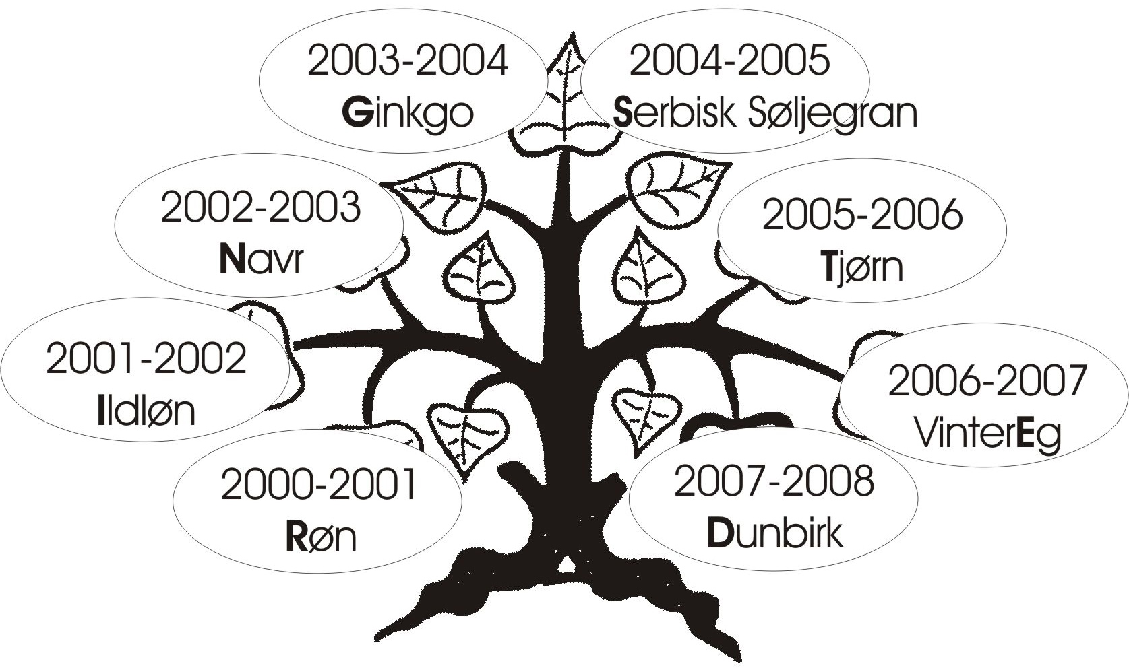RINGSTED
Start with a R – finish with a D

2010 the RINGSTED TREE was inaugurated -
”A green present to the citizens of Ringsted, on the municipality of Ringsted area”.

...3

3...

”RINGSTED TREE” is the only one in Denmark – in the World!? The municipality has by laws said, that : The ”RINGSTED TREE” shall exist in all future.

In 2009 – SI Ringsted - 60 jubilee with 3 subjects:

”ENVIRONMENT” - ”GREEN” - ”MOTION”:
1 Reusable bags produced with Soroptimist-logo, sold at
COP 15 in Copenhagen.Used on SIE- CONGRESS in Denmark
2 Planting a tree,
3 ”Walk the World to stop hunger”

Trafficking - SI Ringsted has participated for several years.100 men put their signature to:”STOP violence to Women”. Denmark’s oldest ”Women Refuge” is supported by SI Ringsted.
2019 – 70 – years jubilee. SI Ringsted had sown bags from advertizing banners. Usually just burnt!

Some lectures in SI Ringsted concerning environment:
Plastic Change, Waste Treatment and Recycling of Plastic, Suncells – Light to Africa, Energy – to the future, Sustainable Rainwater – project, Plastic to debate.

Dnejropetrovsk in Ukraine – our Friendship Club visited DK year 2000; the travel was payed by the Democracy – Fond.
2015: Article in ”Ringstedbogen” 2015 about ”Plant a
tree”(K.I.Callisen)

...4

4

Karen Inger Callisen has been PR – manager and webmaster for many years.
In her job as ergonomist/ physiotherapist has she received the European Price for Work Environment at the Guggenheim Museum, Bilbao.
She was invited to SIE - Vichy France,study at the University Cavilam

SI Ringsted DK is proud to nominate Karen Inger Callisen to present celebration for SI Danmark for 100 years for the Soroptimisme
1921 – 2021

On behalf of SI Ringsted, Denmark,

Grethe Dahl Clemmensen,
President,

E-mail :gdclemmensen@gmail.com

Phone: 45 2179 4711

2020-09-29

