Child ID: 0503741909
December 2022
Your sponsorship for Annija
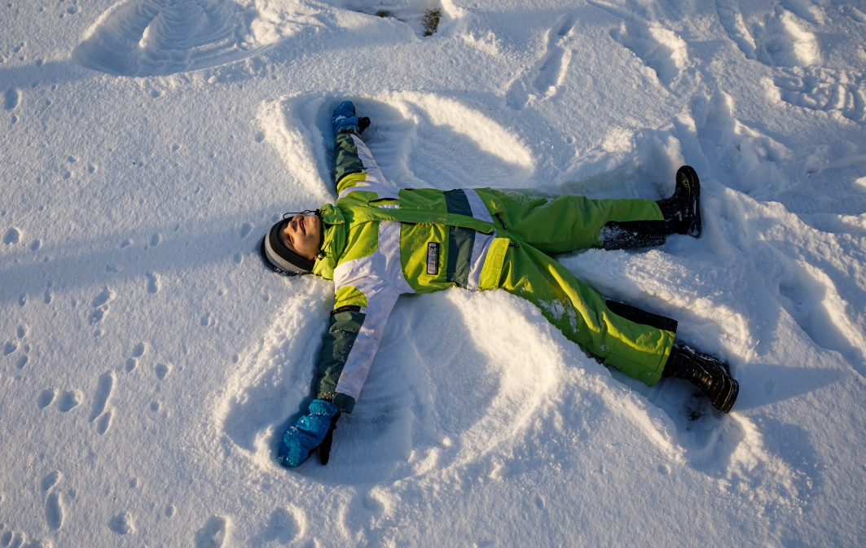
What a great memory from a winter day in childhood - making snow angels

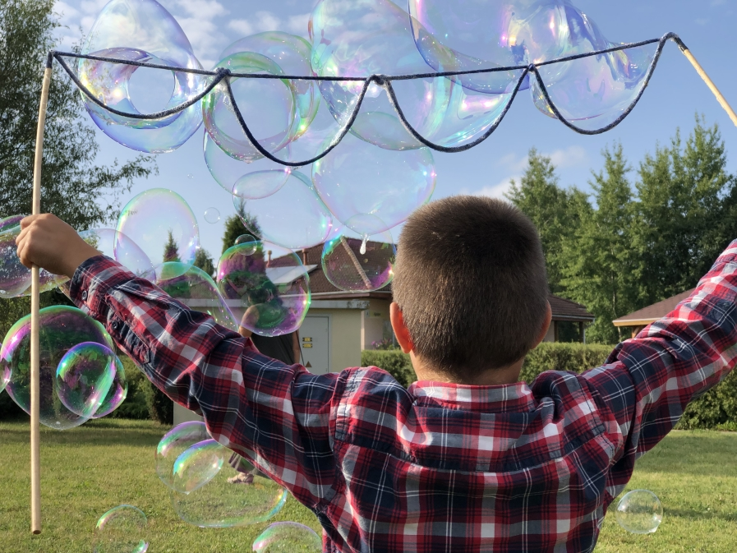
Bubble party was the best event for the children of the village this summer

Dear Friend,

How are you? Are you looking forward to the whitest Christmas full of love this year? I hope you will have them! With a mug of hot cocoa in my hands, I look out the window to the village playground. The world is white with the first snow. Children are playing and enjoying brightness of this sunny day. Their smiles are also bright even if frost pinches a bit their cheeks. Children are safe and happy, thanks to your selfless support. Thank you for being our great friend and supporter!

While waiting for the holidays with the warm flame of candles, I want to tell you some stories from the village ⟮all names of children are changed for data protection⟯. But, at first, some news about your sponsored child.

Annija is in the 1st grade now. Her SOS mom says she is an active, cheerful, friendly, and kind-hearted girl. The girl is proud and excited about her school. 'Annija feels grownup and responsible now. Because she is a student, just like her older siblings,' the SOS mom explains. 'I like everything at my school. All subjects are interesting,' Annija tells. The girl also sings in the school choir, and has joined a folkdance group. After school, she attends trainings at a local basketball school. Her brightest memories from the summer is about the holidays of their family at the seaside. She also enjoyed art and animation workshops.

Celebrating together

We celebrated the 15th anniversary of the village this summer. At the end of August, the weather was very nice. Children had a huge garden party and a concert. 'I was one of the singers in our vocal group,' tells 12 years old Alise. 'It was my first performance for big audience. I was worried, but I think we sang well. People applauded loudly,' she smiles.

Many former children of the village came to the celebration, too. Brothers Aldis and Aivars were happy to meet their SOS mom. The brothers left their SOS family already some years ago. Aldis wanted to continue studies, but Aivars chose to start working.

The boys live independent lives now. Aldis has his own little son, and is happy about it. Aivars works abroad, in another country. He has found his passion – gardening and forestry, and can tell a lot about him. 'Now we understand, how important it was to have our SOS mom. She helped us to grow up and be successful now, in adulthood,' thinks Aldis. 'But I understand it so well only now, when I have a son myself. Parents have so huge impact in everyone's life. We were very lucky to have our SOS mom in our lives.'

Children want to support others, too

Let me tell you about a great initiative coming from the children of the village. This winter, when Christmas are approaching, several children decided to bring happiness to lives of the others. 'Here, in the village, we all have our home, family, friends. But in our town, there are also old people who are lonely at this time. We want to make them feel happier by bringing a small gift or greeting card,' tells 14 years old Alberts, the author of the idea.

'We also want to help animals. Therefore, we asked local animal shelter, what to bring for their cats and dogs. Now we are looking for necessary things for them as well,' adds Simona, his 15 years old friend. Alberts says: 'Our goal is to help those who may be having a harder time these days.' They called their activity 'The joy of creating joy for others'.

There are four children who created this activity. The village social worker Katrina helped them to fullfill their initiative. 'I was glad when children approached me with such a wonderful idea. They asked for an advice how to create a local charity campaign. They made a poster and published it on internet,' she tells. 'It is great that children are thinking about the others!'

We help so many children, thanks to your support!

There are about 130 children living in both villages and youth house. But we support almost 10 times more – in total close to 1300 children and youth in different regions of Latvia. These are children living with guardians, foster or adoptive parents, or coming from socially vulnerable families. This year everybody understood that we can open our hearts wider. Now we also help already more than 500 Ukrainian children who found shelter in Latvia.

I am sending you the best wishes for a safe, healthy, and prosperous new year. I want to share with you a recent photo and a greeting card. Thank you once again for helping to create safe homes for children! We appreciate your support very much!

With warmest regards and wishes from Latvia,
Sandra Braunere
National Sponsorship Co-ordinator

