**Bilag 7**

**Julehilsen fra Halden, Norge**

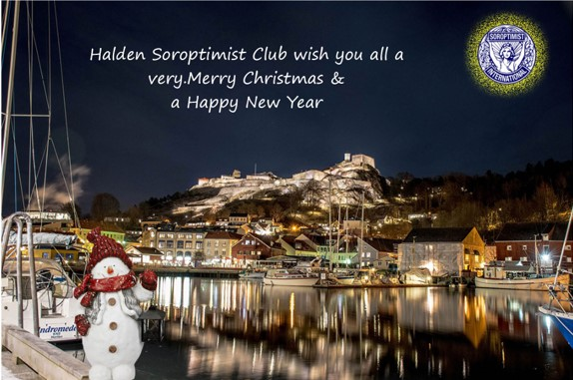

**This has been a very special Halden Soroptimist year as we are sure it has been for you all. The Corona virus put a stop to most of our activities we had planned.**

**We will now give you a brief resume of our year.**

**In 2021 due to Corona Halden Soroptimist Club went digital. Our meetings were held each month using zoom. Our first physical meeting was held outside in June as society gradually opened up.**

**We are all very delighted that one of our members Karin Dahlberg Pettersen is now 1st Vice President of Soroptimist Norway & will become President in 2024 & our club will take on the union leadership.**

**«Orange days» are from the 25th November-9th December where we will be focusing on violence against women with various events, one being, author Hege Duckert who will give a presentation of her book The History of Norwegian Women.**

**Our Skipperstua project is completed & was handed back to Halden community with a ceremony held at Skipperstua with the Mayor of Halden & other guests invited. The project was a great success & became Soroptimist Norway project of the month. Here is a presentation of Skipperstua from last years Christmas greetings.**

"“**Skipperstua”, the project we started in 2016. Skipperstua is a cottage by the water**’**s edge, and is situated on the Hvaler islands. It was given to Halden in 1938, on the understanding that it would be used for holiday accommodation for children & youths who otherwise, would not have a annual holiday. Halden Child Welfare organizes the running of the cottage which can now sleep 20 pers. The cottage was in great need of attention & our club took on the challenge of restoring the cottage ( see Halden Soroptimist Club on face book). We have been busy painting both inside & out. Skipperstua now has running water & a sewage system is installed. Consequently, there is a now a most welcomed bathroom which makes life a lot easier for everyone using the cottage.”**

**I am now happy to say our “Skipperstua” project was completed & handed back to Halden community & we & they are really happy at the result.**

**This is a little information about our club.**

**We would like to wish you all a very Happy Christmas**

**& all good wishes for 2022 & stay healthy.**

**On behalf of Halden Soroptimist Club**

**Inger Marie Papworth & Hilary Selmer-Olsen**

Sendt fra [E-post](https://go.microsoft.com/fwlink/?LinkId=550986) for Windows